Savitribai Phule Pune University



*A PRELIMINARY PROJECT REPORT*

*ON*

**Dynamic Hand Gesture Recognition Using 2D Convolutional Neural Networks and Short-Term Sampling**

Submitted by

**Abhijeet Prasad 72XXXXXXX**

**Satyajit Bhosle 72XXXXXXX**

**Abdul Aseem Shaikh 72025890B**

Under the guidance of

**Prof. S. S. Raskar**



Department of Computer Engineering

Modern Education Society’s

College Engineering, Pune-411 001

[2022-23]

**MODERN EDUCATION SOCIETY’S**

College of Engineering, Pune 01



**C E R T I F I C A T E**

This is to certify that the Project Entitled

DYNAMIC HAND GESTURE RECOGNITION USING 2D CONVOLUTIONAL NEURAL NETWORKS AND SHORT-TERM SAMPLING

Submitted by

Abhijeet Prasad Exam No: 72XXXXXXX

Satyajit Bhosle Exam No: 72XXXXXXX

Abdul Aseem Shaikh Exam No: 72025890B

*is a bonafide work carried out by Students under the supervision of Prof. Guide Name and it is submitted towards the partial fulfillment of the requirement of Bachelor of Engineering (Computer Engineering).*

**(Prof. S. S. Raskar)** **(Dr. N. F. Shaikh)**

Guide Head,

Department of Computer Engineering Department of Computer Engineering

**(Dr. M. P. Dale)**

Principal,

MES College of Engineering Pune – 01

Place : Pune

Date :

**ACKNOWLEDGEMENT**

We would like to express our deep sense of gratitude towards our project guide Prof. S. S. Raskar for her support, continuous guidance and for being so understanding and

helpful throughout the course of this project.

We have furthermore to thank Computer Department HOD Dr.(Mrs.) N. F. Shaikh to

encourage us to go ahead and for continuous guidance. We also want to thank Dr. (Mrs.)

S.P. Deore for all her assistance and guidance for preparing the report.

We would like to thank all those, who have directly or indirectly helped us for the completion of the work during this project.

**ABHIJEET PRASAD**

**SATYAJIT BHOSLE**

**ABDUL ASEEM SHAIKH**

**ABSTRACT**

Hand gestures are a natural way for human-robot interaction. Vision based dynamic hand gesture recognition has become a hot research topic due to its various applications.

This project presents a network for hand gesture recognition. The network integrates several modules together to learn both short-term and long-term features from video inputs. A substantial aim is to minimize intensive computation, since handling the video inputs can be an exhausting and computationally expensive task.

Short-term features are learned by segmenting the video input into a fixed number of frames. Then, a frame is randomly selected and represented both, as an RGB(Red, Green, Blue colour channels) image and an optical flow snapshot. These two, i.e., RGB image and optical flow snapshot, are then fused and fed into a convolutional neural network(CNN) for the purpose of feature extraction.

Long-term features are learned by a similar process. The outputs from all the convolutional neural networks are fed into a long short term memory (LSTM) network, and a hence a final classification result is obtained.

As an application to extend the scope of the project, we intend to use the hand gestures classified to perform basic system control.

# INTRODUCTION

## MOTIVATION

**PROBLEM DEFINITION**

**LITERATURE SURVEY**

Zhang, *et al.* Designed a 3-dimensional convolutional neural network model(CNN) [1], this study applies a deep learning method to recognise hand gestures. 3D Convolution neural network can be seen as a variant of 2D convolution neural network extending 2dimension filter into 3 dimensions. This 3D filter shall slide in 3 directions to extract low-level features and its output’s shape is a 3dimension space like a cuboid Uses the Jester V1.0 hand gesture dataset to train the model. According to the result of the training experiment, it got an average accuracy of 90%.

Wang *et al.* developed temporal segment networks (TSN) in [2], for action recognition. In the TSN model, each input video sample is divided into a number of segments and a short snippet is randomly selected from each segment. The snippets are represented by modalities such as RGB frames, optical flow and RGB differences. Convolutional neural networks (ConvNets) that are used to learn these snippets all share parameters. The class scores of different snippets are fused by the segmental consensus function to yield segmental consensus, which is a video-level prediction. Predictions from all modalities are fused to produce the final prediction. Experiment showed that the model not only achieved very good action recognition accuracy but also maintained reasonable computation cost.

Min, *et al.* [3] formulate gesture recognition as an irregular sequence recognition problem and aim to capture long-term spatial correlations across point cloud sequences. A novel and effective PointLSTM is proposed to propagate information from past to future while preserving the spatial structure. The proposed PointLSTM combines state information from neighboring points in the past with current features to update the current states by a weight-shared LSTM layer. This method can be integrated into many other sequence learning approaches. In the task of gesture recognition, the proposed PointLSTM achieves state-of-the-art results on two challenging datasets (NVGesture and SHREC'17) and outperforms previous skeleton-based methods. To show its advantages in generalization, we evaluate our method on MSR Action3D dataset, and it produces competitive results with previous skeleton-based methods.

Tang, *et al.* [4] combined image entropy and density clustering to exploit the key frames from hand gesture video for further feature extraction, which can improve the efficiency of recognition. Moreover, a feature fusion strategy is also proposed to further improve feature representation, which elevates the performance of recognition. To validate our approach in a "wild" environment, we also introduce two new datasets called HandGesture and Action3D datasets. Experiments consistently demonstrate that our strategy achieves competitive results on Northwestern University, Cambridge, HandGesture and Action3D hand gesture datasets

Cheng, *et al.* [5] proposed a Dynamic Graph-Based Spatial-Temporal Attention (DG-STA) method for hand gesture recognition. The key idea is to first construct a fully-connected graph from a hand skeleton, where the node features and edges are then automatically learned via a self-attention mechanism that performs in both spatial and temporal domains. We further propose to leverage the spatial-temporal cues of joint positions to guarantee robust recognition in challenging conditions. In addition, a novel spatial-temporal mask is applied to significantly cut down the computational cost by 99%. We carry out extensive experiments on benchmarks (DHG-14/28 and SHREC'17) and prove the superior performance of our method compared with the state-of-the-art methods.

Zhang, Wang, Lan [6]

Presents a novel deep learning network for hand gesture recognition. The network integrates several well- proved modules together to learn both short-term and long-term features from video inputs and meanwhile avoid intensive computation. To learn short-term features, each video input is segmented into a fixed number of frame groups. A frame is randomly selected from each group and represented as an RGB image as well as an optical flow snapshot. These two entities are fused and fed into a convolutional neural network (ConvNet) for feature extraction. The ConvNets for all groups share parameters. To learn longterm features, outputs from all ConvNets are fed into a long short-term memory (LSTM) network, by which a final classification result is predicted. The new model has been tested with two popular hand gesture datasets, namely the Jester dataset and Nvidia dataset. The robustness of the model has also been proved with an augmented dataset with enhanced diversity of hand gestures. Uses the Jester dataset and Nvidia Dataset Achieved an accuracy if around 95%(Jester dataset) and 85%(Nvidia dataset).

**SOFTWARE REQUIREMENT SPECIFICATION**

**Introduction :**

**Project Scope:**

We trying to build a system which can provide contactless interaction between user and physical hardware of any machine where user need to navigate through the interface like our personal computer, laptop, and ATM machine.

**User Classes and Characteristics:**

Users who can perform hand gesture can make use of this system to navigate through the OS without making any physical contact to the physical hardware. User will need to perform meaning or proper gesture to navigate through OS.

**Assumptions And Dependencies:**

We are going to assume that user’s machine have already install all the necessary software like .Net frame work, C++ redistribution (2019) and all the necessary driver related to webcam or any optical camera for capturing the user’s gestures.

**Functional requirements**

Feature vector extraction: For feature vector extraction we require the CNN model. For our project we are going to use 2D CNN model for feature extraction.

Video sequence: For video sequence we need the webcam. Which will capture the gesture/moment of user’s hand.

Gesture classification: For classification we required RNN model. We will be using LSTM model for gesture classification.

Mapping gesture to OS operation: For Mapping particular gesture to perform OS navigation operation we will need the OpenCV library.

**External Interface Requirements:**

User Interfaces: User need to the perform the valid gesture to navigate through operating system.

Hardware Interface: Webcam is required for capturing the video stream of the user who is performing the gesture. And webcam should have recording speed of 30 FPS at least

Software Interface: OpenCV is require for mapping the particular gesture to the OS navigation operation.

**Non-Functional requirements:**

Performance Requirement: Video stream should be capture at the speed of 30FPS.

Safety Requirement: No safety risk expected.

Security Requirement: No user personal data or any image will be saved by the system.

Software quality attributes: Usability, Reliability, Protability, Testibility, Flexibility;

**System Requirement:**

Software Requirements:

Operating System: Windows 10.

Programming Language: Python.

Library: OpenCV, TensorFlow, Pandas, Numpy,Keras.

Hardware Requirements:

CPU: DUO core (of 4 generation or above).

Ram: 4GB or above.

Graphic Card (for training & testing and neural network ): GT 1050 or Intel 520.

Storage: 500GB HDD or SDD.

Webcam: should able to recording at 30FPS (Frame Per second).

**Analysis Models: SDLC description**

We will be following the water fall model for our software development life-cycle. The waterfall model is a continuous software development model in which development is seen as flowing steadily downwards (like a waterfall) through the steps of requirements analysis, design, implementation, testing (validation), integration, and maintenance.

Linear ordering of activities has some significant consequences. First, to identify the end of a phase and the beginning of the next, some certification techniques have to be employed at the end of each step. Some verification and validation usually do this mean that will ensure that the output of the stage is consistent with its input (which is the output of the previous step), and that the output of the stage is consistent with the overall requirements of the system.

Phases in Waterfall Model:

**Requirements analysis and specification phase:** The aim of this phase is to understand the exact requirements of the customer and to document them properly. Both the customer and the software developer work together so as to document all the functions, performance, and interfacing requirement of the software. It describes the "what" of the system to be produced and not "how."In this phase, a large document called **Software Requirement Specification (SRS)** document is created which contained a detailed description of what the system will do in the common language.

**Design Phase:** This phase aims to transform the requirements gathered in the SRS into a suitable form which permits further coding in a programming language. It defines the overall software architecture together with high level and detailed design. All this work is documented as a Software Design Document (SDD).

**3. Implementation and unit testing:** During this phase, design is implemented. If the SDD is complete, the implementation or coding phase proceeds smoothly, because all the information needed by software developers is contained in the SDD.

**4. Integration and System Testing:** This phase is highly crucial as the quality of the end product is determined by the effectiveness of the testing carried out. The better output will lead to satisfied customers, lower maintenance costs, and accurate results. Unit testing determines the efficiency of individual modules. However, in this phase, the modules are tested for their interactions with each other and with the system.

**5. Operation and maintenance phase:** Maintenance is the task performed by every user once the software has been delivered to the customer, installed, and operational.

**System Implementation Plan: description of goals procedure etc.**

**SYSTEM DESIGN**

System Architecture:

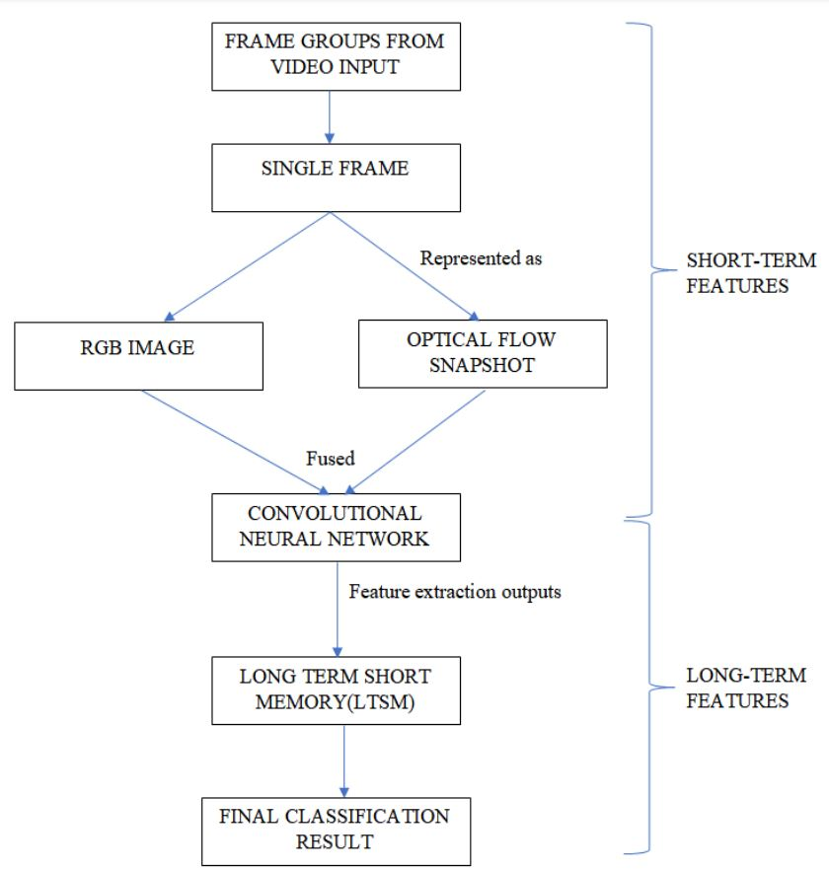

Figure. Architecture Diagram.

Dataflow Diagrams:

Level 0 Dataflow diagrams:

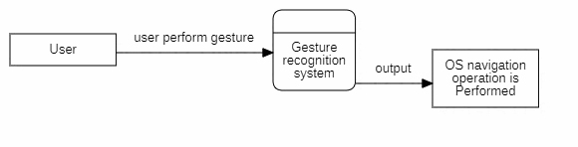

Figure. Level 0 dataflow diagram.

Level 1 Dataflow diagrams:

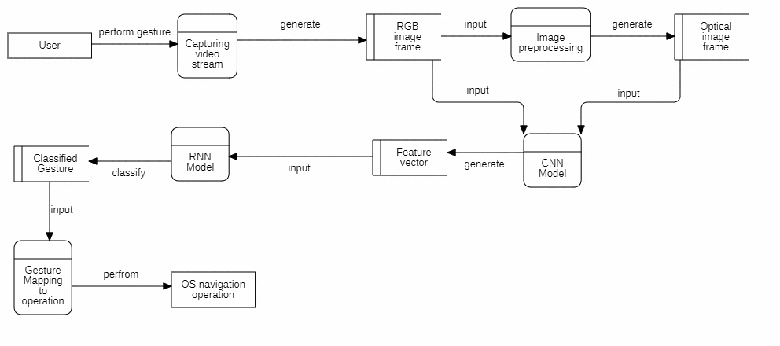

Figure. Level 1 Dataflow diagram.

Level 2 Dataflow diagrams:

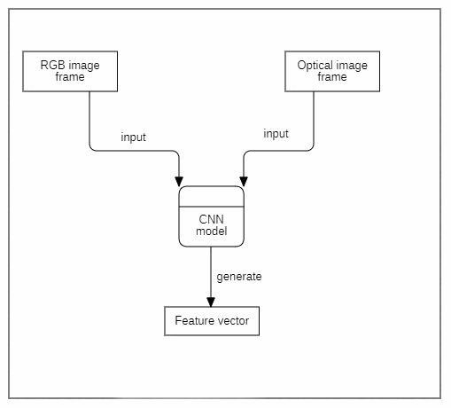

Figure. Level 2 Dataflow Diagram: generating feature vector.

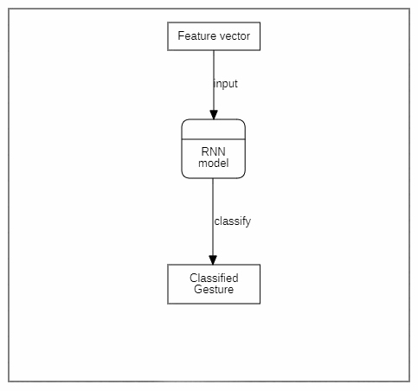

Figure. Level 2 dataflow diagram: classification.

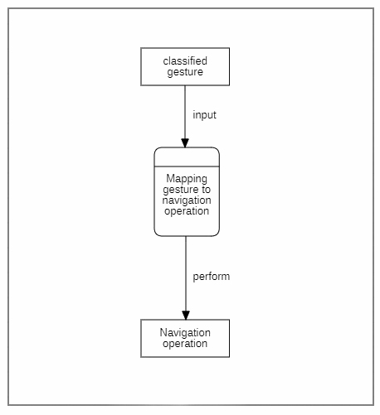

Figure. Level 2 dataflow diagram: mapping gesture to operation

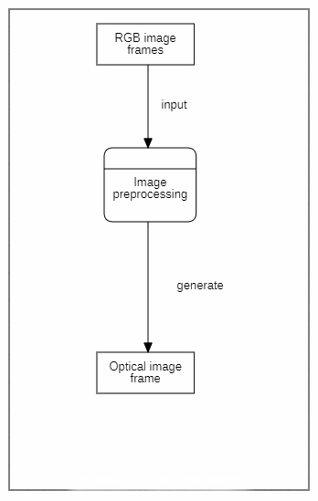

Figure. Leve 2 dataflow diagram: generating optical image.

Entity Relationship Diagram:

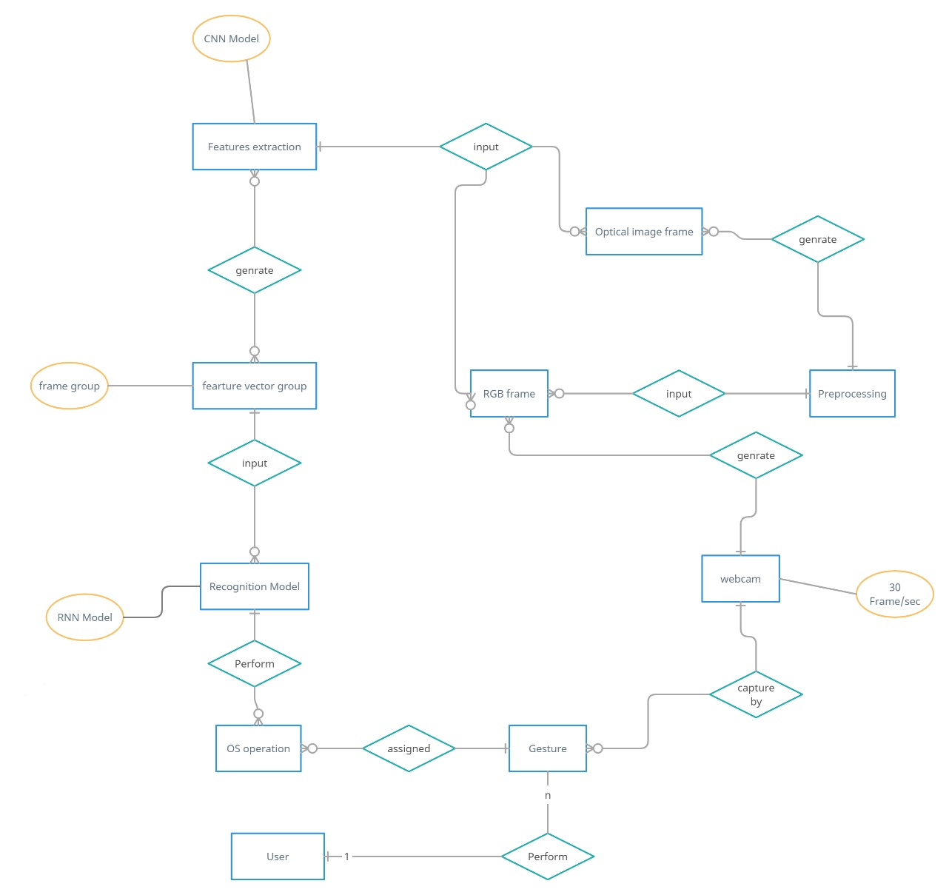

Figure. Entity Relationship diagram

UML Diagram:

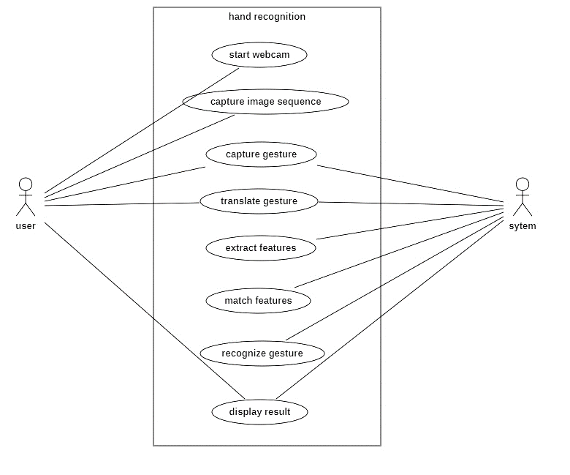

Figure. Use Case diagram

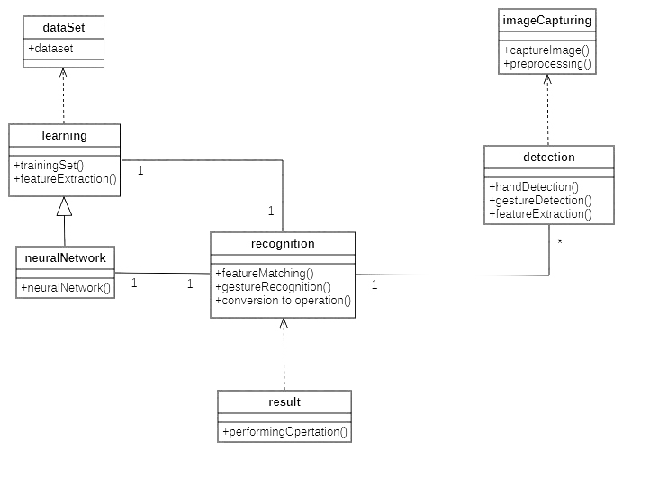

Figure. Class Diagram

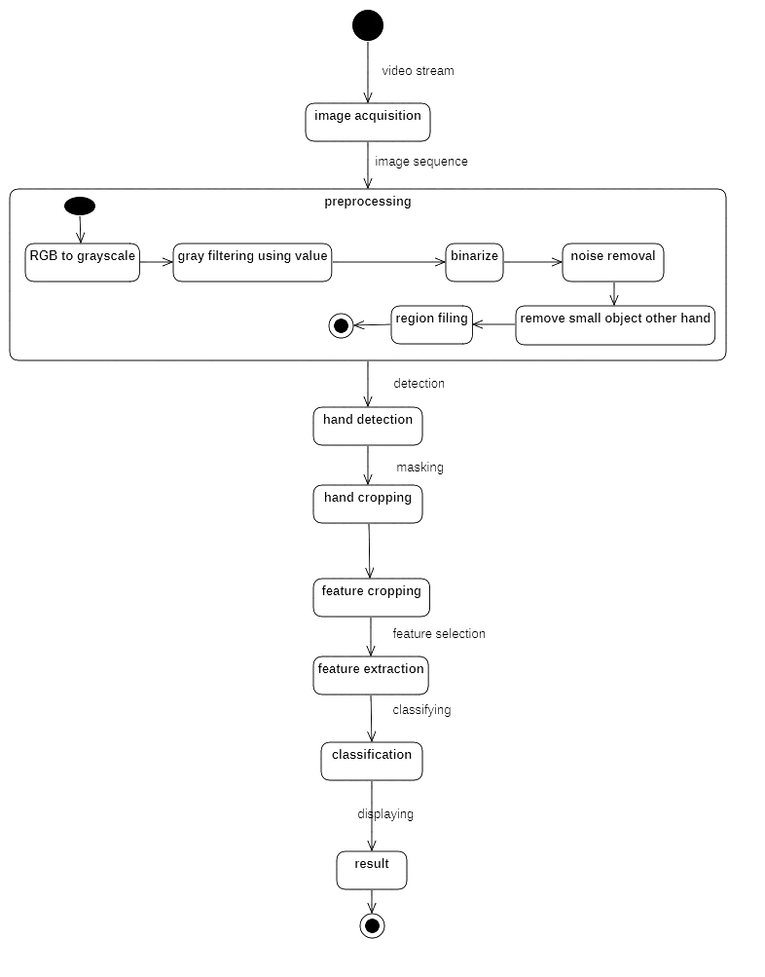

Figure. State Diagram

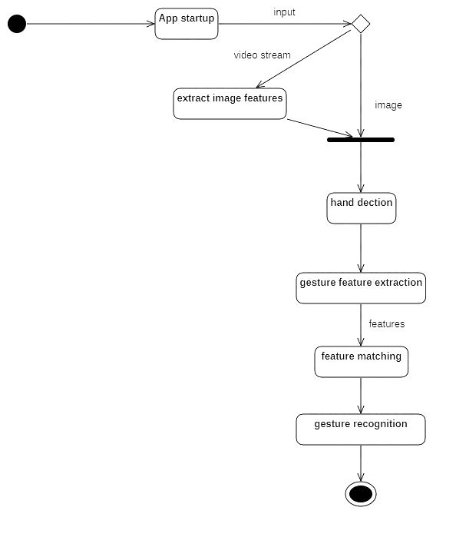

Figure. Activity Diagram

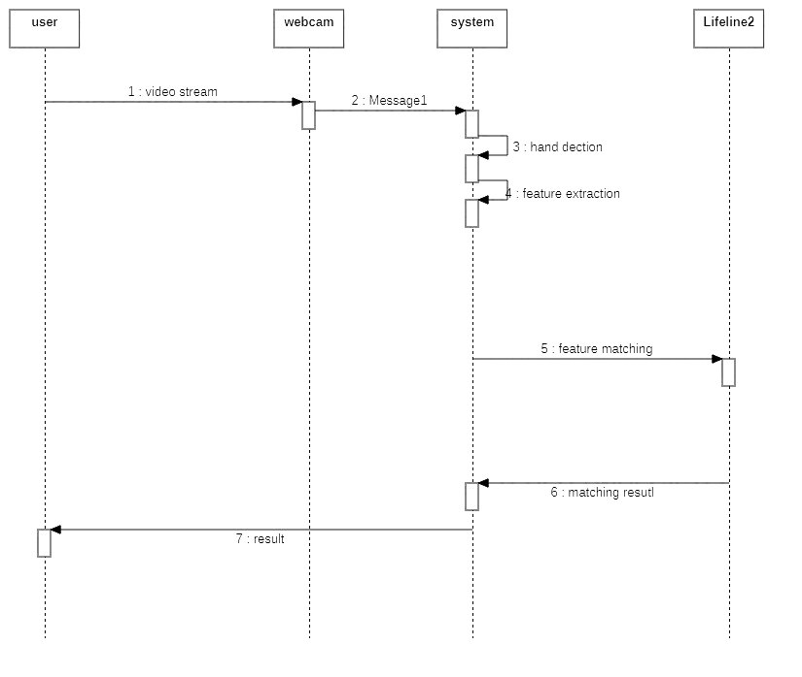

Figure. Sequence Diagram

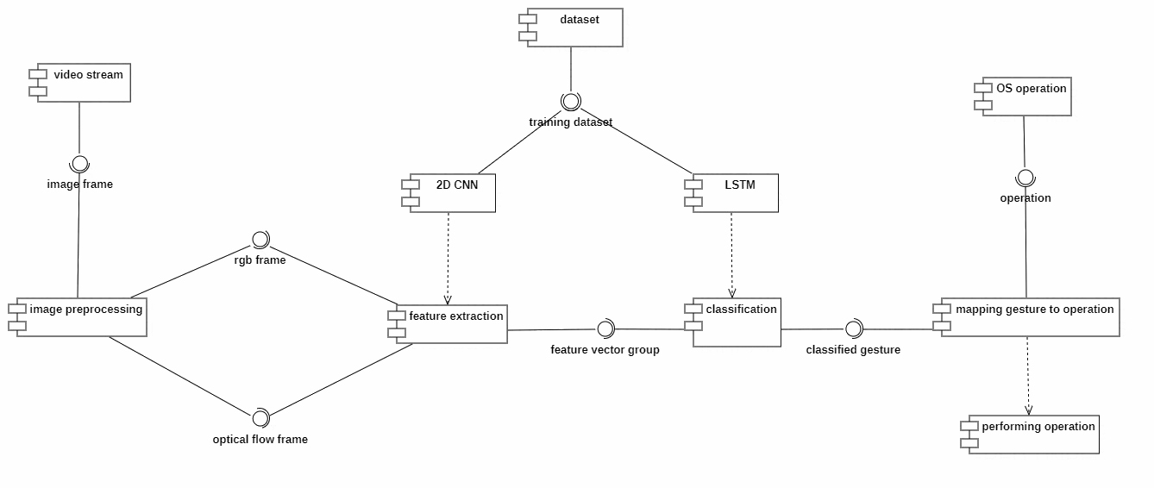

Figure. Component Diagram

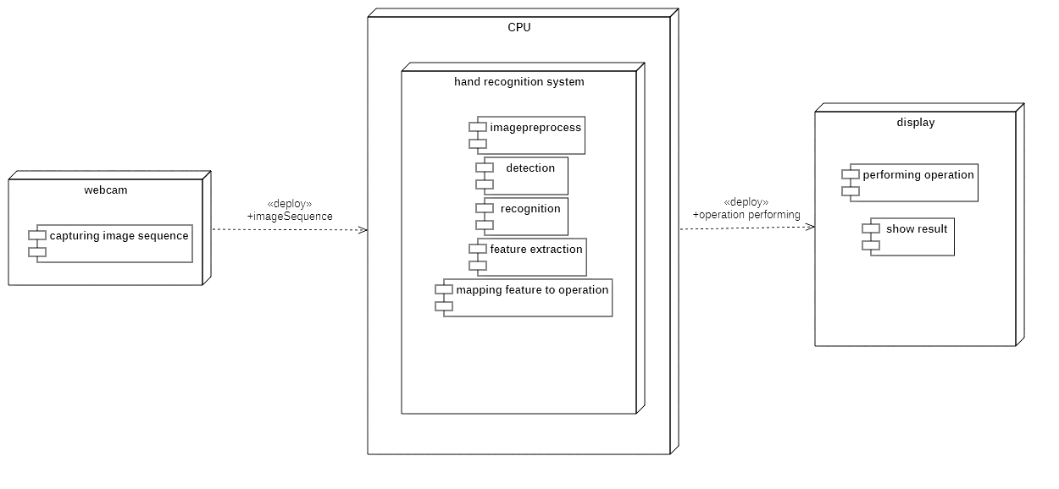

Figure. Deployment Diagram

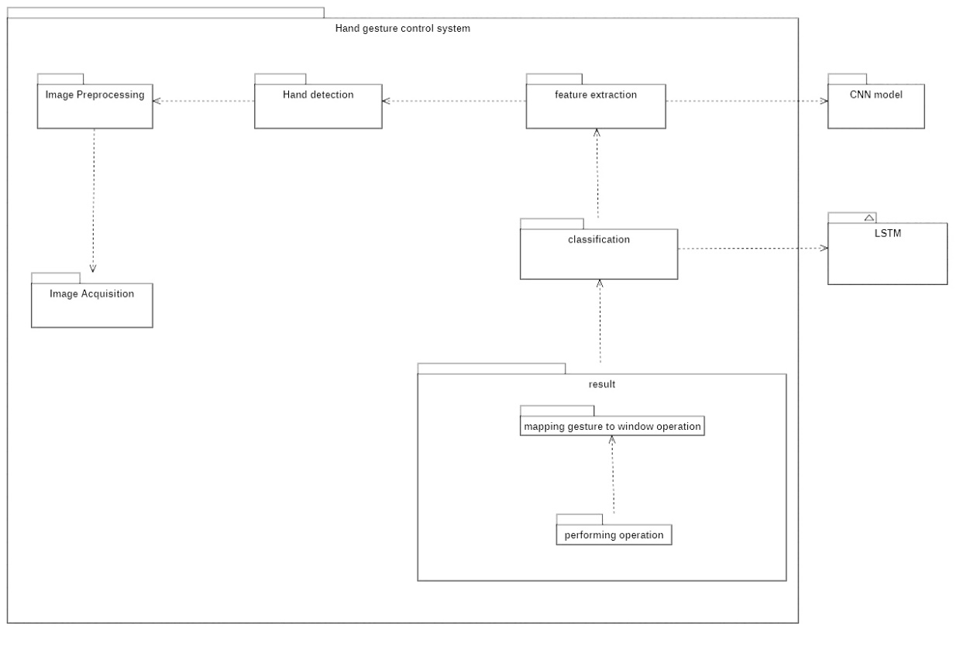

Figure. Package diagram

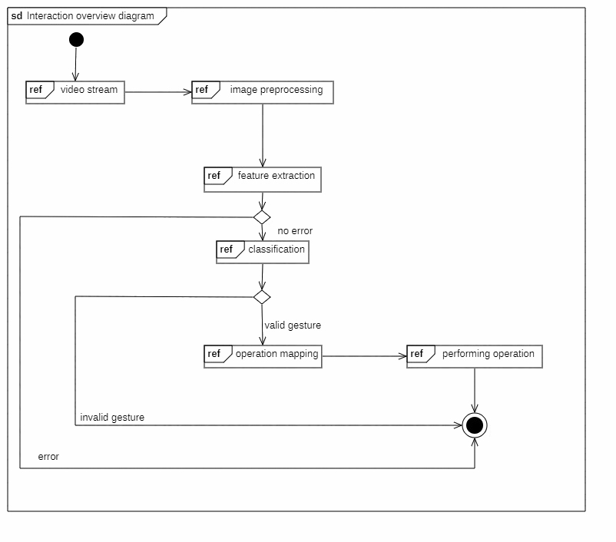

Figure. Interaction Over View.

**OTHERS SPECIFICATION**

Advantages:

Limitation:

Application:

**CONCLUSION AND FUTURE WORKS**

In future we can map more gesture to different navigation operation which can we user more control of the screen. And we can decrease the latency by increasing the training dataset and Neural Network nodes.

Appendix A:

Appendix B:

Appendix C: